April 2, 2023
Coming Up...
Apr 2 - 1 Peter 2:13-17
Apr 7 - Good Friday Service at Full Gospel
Apr 9 - 500 Reasons to Believe the Resurrection of Jesus - Acts 1:1-11
Meet and Greet from 10:00-10:20am has been going great! Come visit and meet some of the new people at Church!
On the Calendar:
Mar 29 (Wed) @ 7:00pm - Evening Prayer & Bible Study
Apr 1 (Sat) @ 10:30am - Sonshine Saturday
Apr 1 (Sat) @ 8:30am - Men's Prayer Time
Apr 2 (Sun) @ 10:30am - Worship/Communion/Benevolent/Luncheon
Apr 4 (Tue) @ 1:30pm - packaging cookies @ DFBC
Apr 7 (Fri) @ 10:30 @ Full Gospel - Good Friday Service
Apr 9 (Sun) @ 10:30am - Easter!! He is Risen!! Worship
Apr 21 (Fri) @ 7:00pm - Fired Up Fridays
Apr 22 (Sat) @ 1:00 - 3:00pm - Ladies’ Fellowship and Bible Study
Apr 28 (Fri) @ 7:00pm – Ladies’ Inter-Church Tea

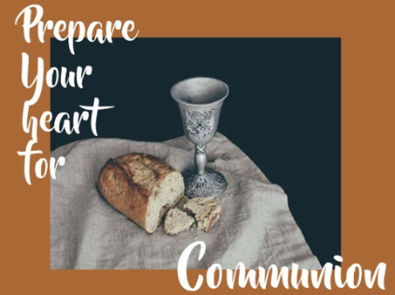
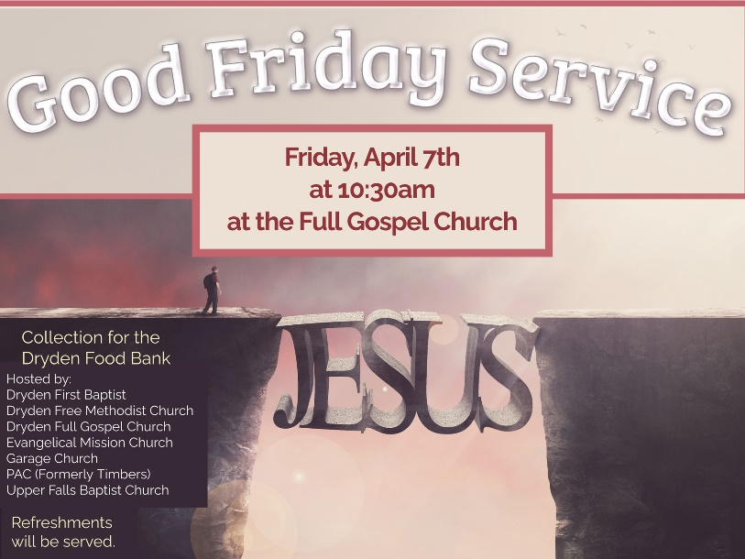
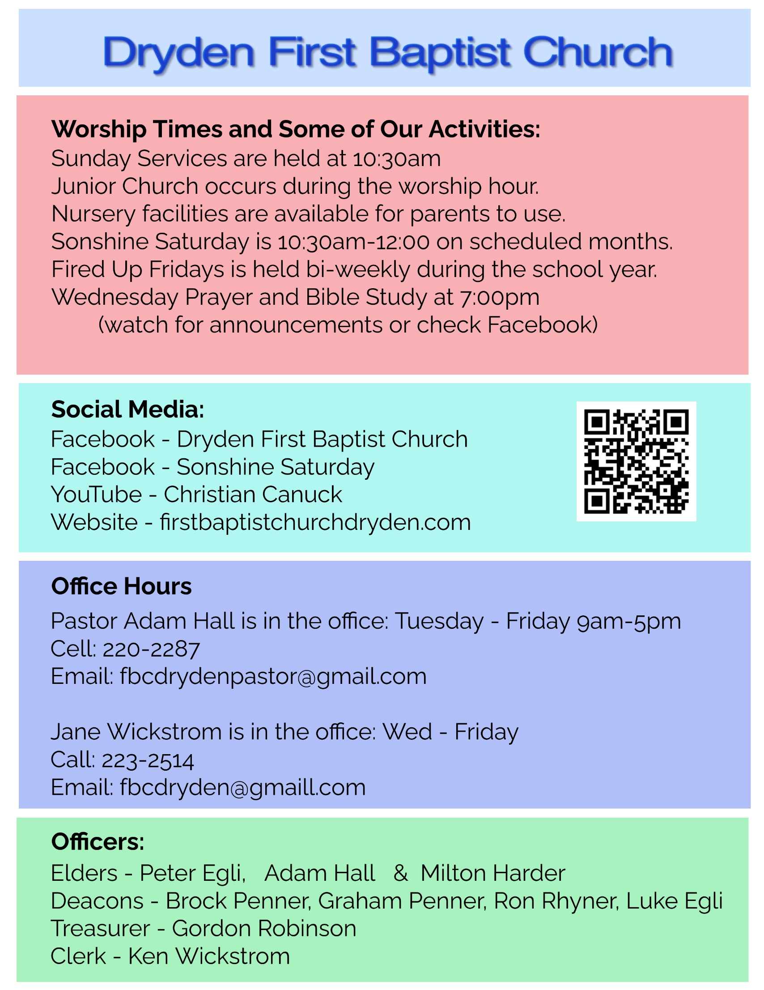
Sermon Outline

Fear The Lord Not The Government: 1 Peter 2:13-17 ESV
Pastor Adam Hall Dryden First Baptist Church April 2, 2023

1 Peter 2:13-17 ESV
¹³ Be subject for the Lord's sake to every human institution, whether it be to the emperor as supreme, ¹⁴ or to governors as sent by him to punish those who do evil and to praise those who do good. ¹⁵ For this is the will of God, that by doing good you should put to silence the ignorance of foolish people. ¹⁶ Live as people who are free, not using your freedom as a cover-up for evil, but living as servants of God. ¹⁷ Honor everyone. Love the brotherhood. Fear God. Honor the emperor.

Introduction

1 Peter 1:6 In this you rejoice, though now for a little while, if necessary, you have been grieved by various trials,

1 Peter 4:12-13 Beloved, do not be surprised at the fiery trial when it comes upon you to test you, as though something strange were happening to you. ¹³ But rejoice insofar as you share Christ's sufferings, that you may also rejoice and be glad when his glory is revealed.

1 Peter 5:9 Resist him, firm in your faith, knowing that the same kinds of suffering are being experienced by your brotherhood throughout the world.

Review

1 Peter 2:11-12 Beloved, I urge you as sojourners and exiles to abstain from the passions of the flesh, which wage war against your soul. ¹² Keep your conduct among the Gentiles honorable, so that when they speak against you as evildoers, they may see your good deeds and glorify God on the day of visitation.

1) (2:13-14) Subject
(2:13) Be subject for the Lord's sake to every human institution, whether it be to the emperor as supreme,

James 4:7 Submit yourselves therefore to God. Resist the devil, and he will flee from you.

1 Peter 2:18 Servants, be subject to your masters with all respect, not only to the good and gentle but also to the unjust.

1 Peter 3:1 Likewise, wives, be subject to your own husbands, so that even if some do not obey the word, they may be won without a word by the conduct of their wives,

1 Peter 5:5 Likewise, you who are younger, be subject to the elders. Clothe yourselves, all of you, with humility toward one another, for "God opposes the proud but gives grace to the humble."

Hebrews 11:23 By faith Moses, when he was born, was hidden for three months by his parents, because they saw that the child was beautiful, and they were not afraid of the king's edict.

Exodus 1:17 But the midwives feared God and did not do as the king of Egypt commanded them, but let the male children live.

Acts 4:18-20 So they called them and charged them not to speak or teach at all in the name of Jesus. ¹⁹ But Peter and John answered them, "Whether it is right in the sight of God to listen to you rather than to God, you must judge, ²⁰ for we cannot but speak of what we have seen and heard."

(2:14) or to governors as sent by him to punish those who do evil and to praise those who do good.

Romans 13:1-7 Let every person be subject to the governing authorities. For there is no authority except from God, and those that exist have been instituted by God. ² Therefore whoever resists the authorities resists what God has appointed, and those who resist will incur judgment. ³ For rulers are not a terror to good conduct, but to bad. Would you have no fear of the one who is in authority? Then do what is good, and you will receive his approval, ⁴ for he is God's servant for your good. But if you do wrong, be afraid, for he does not bear the sword in vain. For he is the servant of God, an avenger who carries out God's wrath on the wrongdoer. ⁵ Therefore one must be in subjection, not only to avoid God's wrath but also for the sake of conscience. ⁶ For because of this you also pay taxes, for the authorities are ministers of God, attending to this very thing. ⁷ Pay to all what is owed to them: taxes to whom taxes are owed, revenue to whom revenue is owed, respect to whom respect is owed, honor to whom honor is owed.

2) (2:15) Silence
For this is the will of God, that by doing good you should put to silence the ignorance of foolish people.

3) (2:16) Servants of God
Live as people who are free, not using your freedom as a cover-up for evil, but living as servants of God.

1 Peter 1:18-19 knowing that you were ransomed from the futile ways inherited from your forefathers, not with perishable things such as silver or gold, ¹⁹ but with the precious blood of Christ, like that of a lamb without blemish or spot.

4) (2:17) Superior Fear
Honor everyone. Love the brotherhood. Fear God. Honor the emperor.

#1) Honour Everyone

Genesis 1:26-27 Then God said, "Let us make man in our image, after our likeness. And let them have dominion over the fish of the sea and over the birds of the heavens and over the livestock and over all the earth and over every creeping thing that creeps on the earth." ²⁷ So God created man in his own image, in the image of God he created him; male and female he created them.

#2) Love the Brotherhood

John 13:34 A new commandment I give to you, that you love one another: just as I have loved you, you also are to love one another.

#3) Fear God

Proverbs 1:7 The fear of the LORD is the beginning of knowledge; fools despise wisdom and instruction.
Psalm 2:11 Serve the LORD with fear, and rejoice with trembling.

#4) Honor the Emperor

Application
- Do You Know The Freedom of Christ?

Galatians 5:1 For freedom Christ has set us free; stand firm therefore, and do not submit again to a yoke of slavery.

2) Glorify God With Your Life

3) Submission and Honour to the Government

- Be Honest about paying your taxes

Matthew 22:21 They said, "Caesar's." Then he said to them, "Therefore render to Caesar the things that are Caesar's, and to God the things that are God's."

2) Pray for your government
1 Timothy 2:1-3 First of all, then, I urge that supplications, prayers, intercessions, and thanksgivings be made for all people, ² for kings and all who are in high positions, that we may lead a peaceful and quiet life, godly and dignified in every way. ³ This is good, and it is pleasing in the sight of God our Savior,

- Next Sunday’s text: 500 Reasons to Believe in the Resurrection: Acts 1:1-11
- Invite someone to attend next week for a special Easter message.

