May 14, 2023
Welcome

Coming Up...
May 21 – 1 Peter 3:18-20
May 28 – 1 Peter 3:21-22
Meet and Greet from 10:00-10:20am has been going great! Come visit and meet some of the new people at Church!

On the Calendar:
May 14 (Sun) @ 7:00pm - Watoto at Dryden Full Gospel Church
May 14 (Sun) @ 3:30pm - Princess Court Service (Contact: Gord Robinson)
May 17 (Wed) @ 7:30am - Men’s Bible Study
May 17 (Wed) @ 7:00pm - Evening Prayer & Bible Study
May 19 (Fri) @ 1:00pm - Church Revitalization Meeting
May 19 (Fri) @ 7:00pm - Fired Up Friday
May 20 (Sat) @ 8:30am - Men's Prayer Time
May 21 (Sun) @ 10:00am - Meet and Greet!
May 21 (Sun) @ 6:30pm - Freedom Church (Adult and Teen Challenge)
May 27 (Sat) @ 1:00pm - Ladies' Fellowship and Bible Study
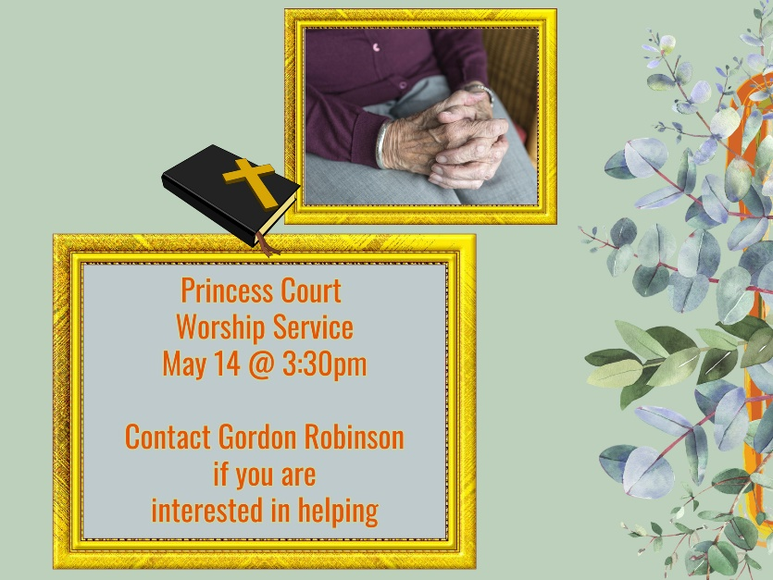
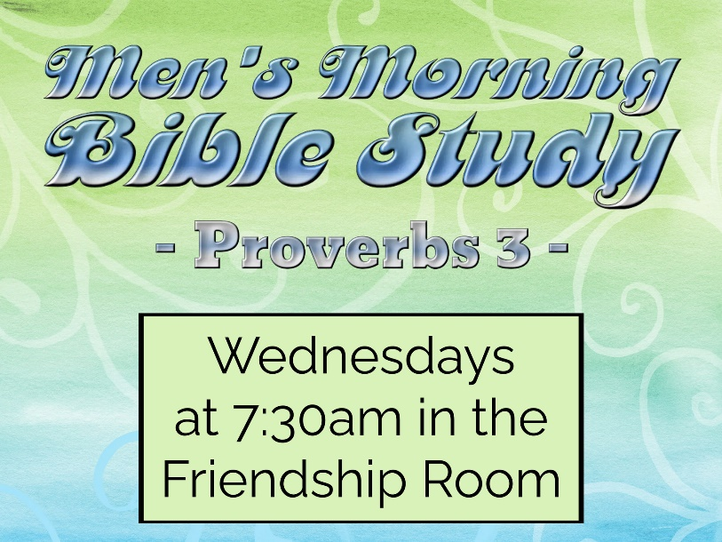
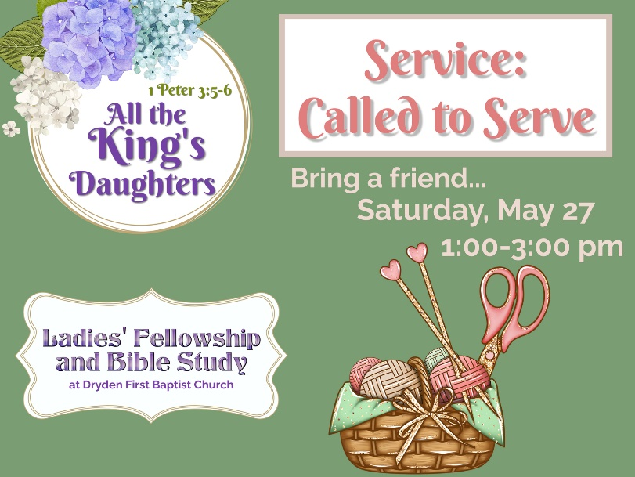
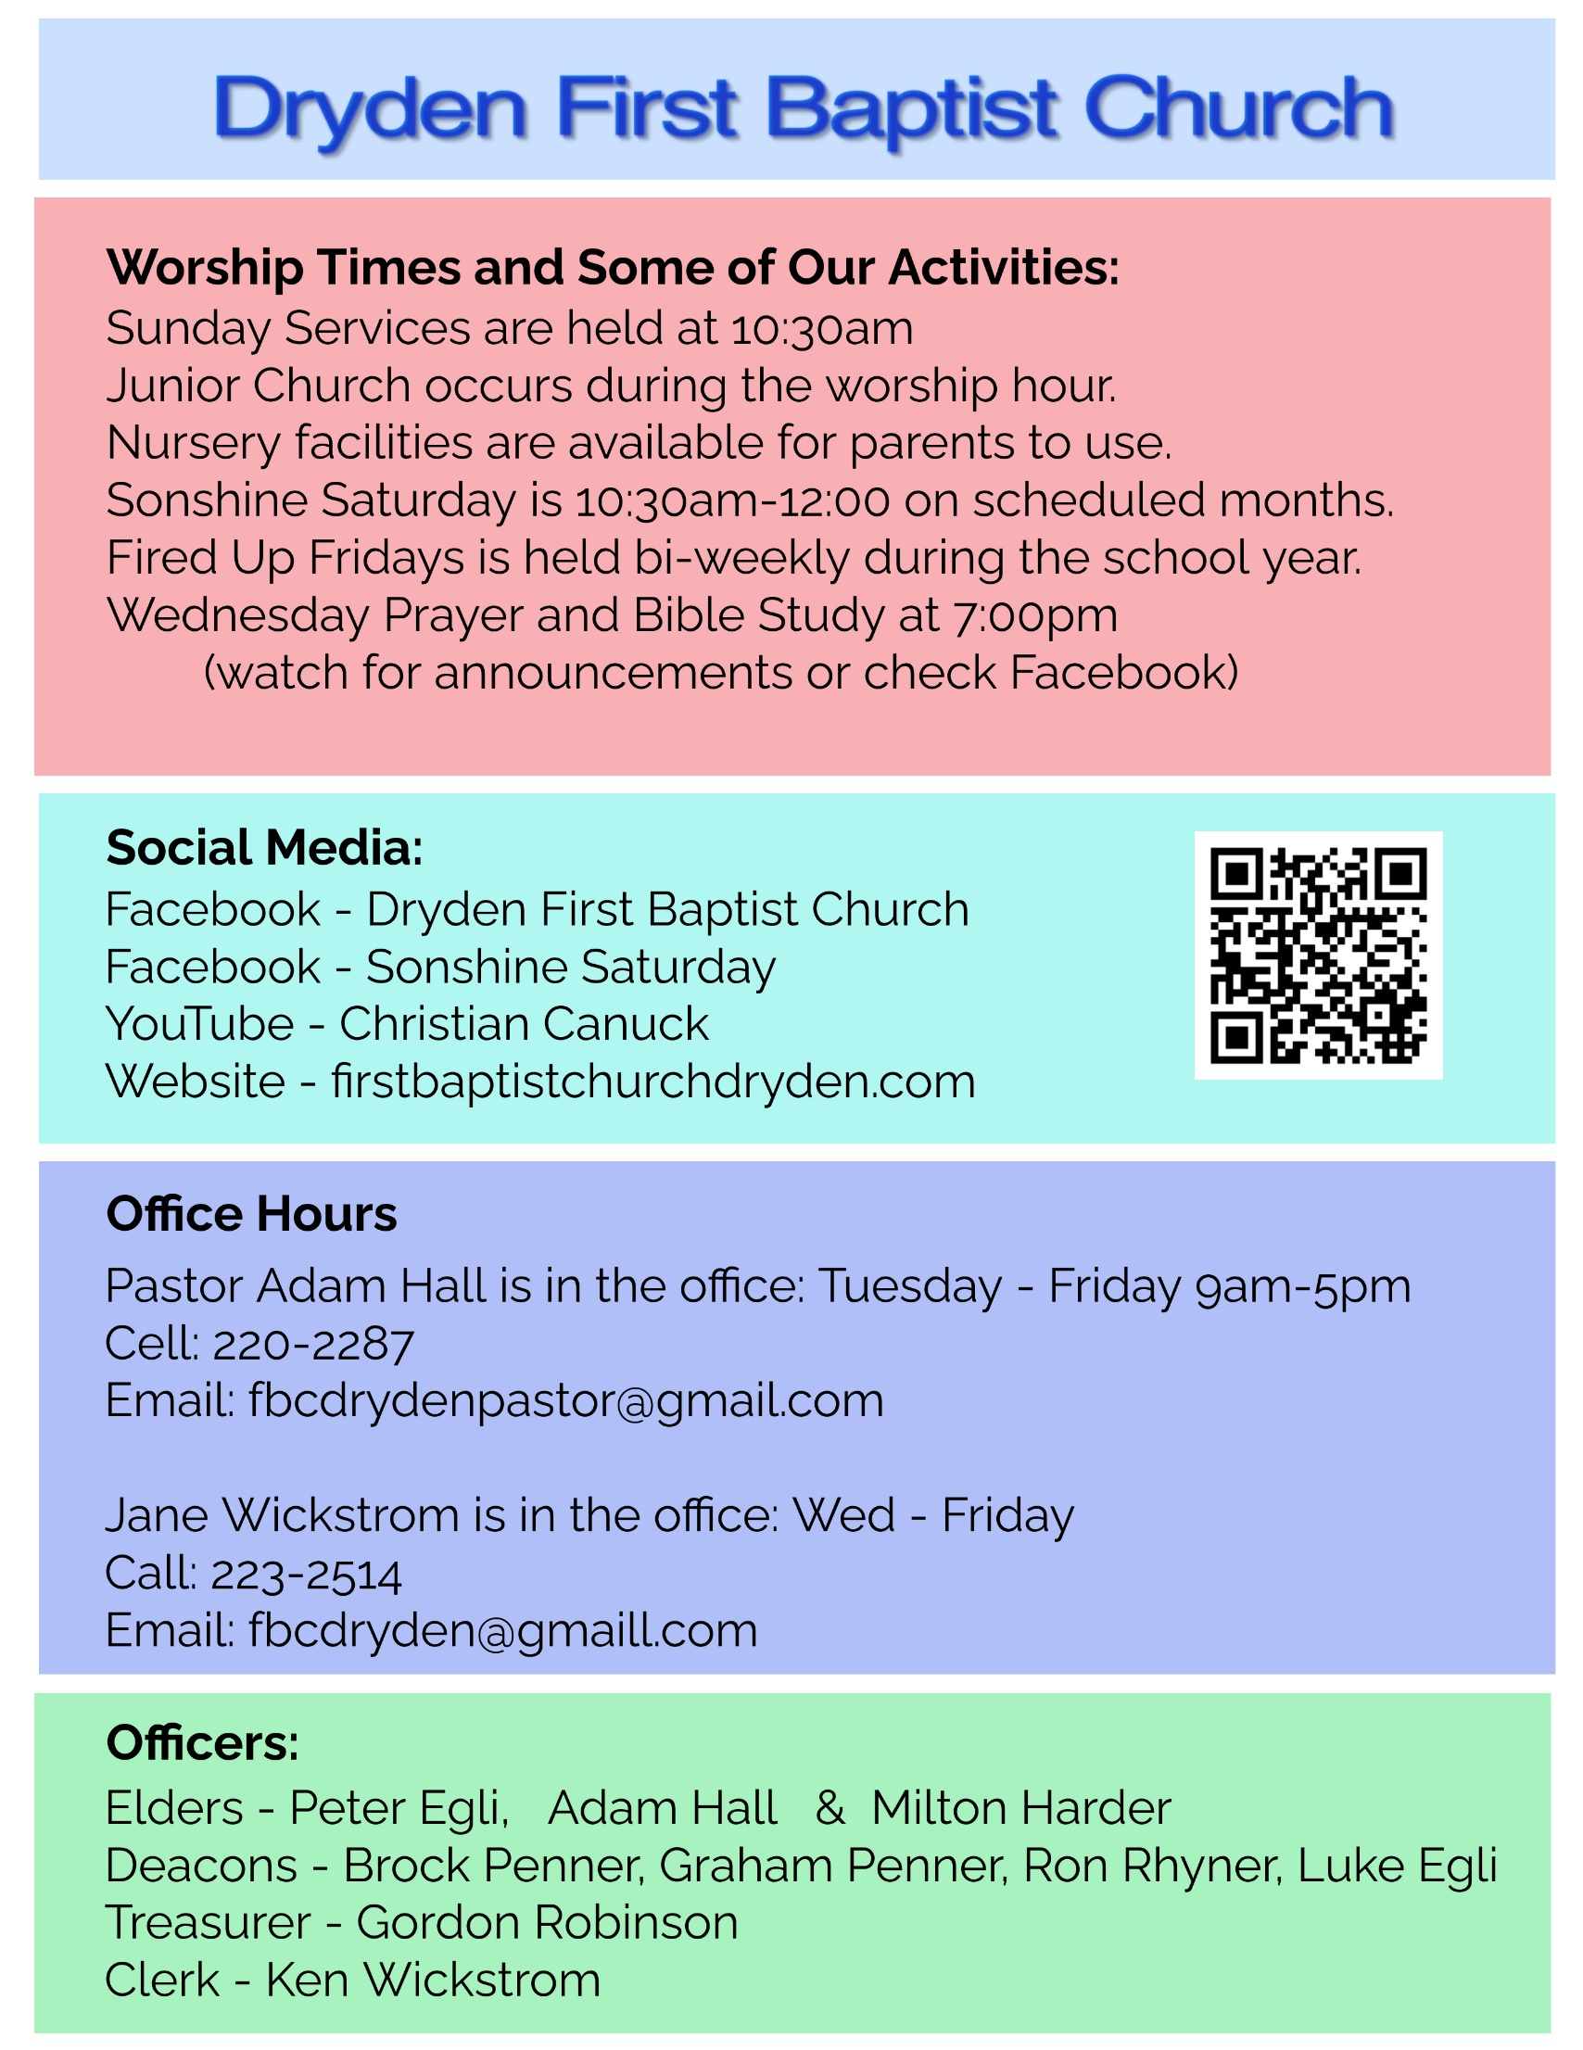
Sermon Outline

Defending Your Faith Even If You Suffer: 1 Peter 3:13-17
Pastor Adam Hall Dryden First Baptist Church May 14, 2023

1 Peter 3:13-17 ESV
¹³ Now who is there to harm you if you are zealous for what is good? ¹⁴ But even if you should suffer for righteousness' sake, you will be blessed. Have no fear of them, nor be troubled, ¹⁵ but in your hearts honor Christ the Lord as holy, always being prepared to make a defense to anyone who asks you for a reason for the hope that is in you; yet do it with gentleness and respect, ¹⁶ having a good conscience, so that, when you are slandered, those who revile your good behavior in Christ may be put to shame. ¹⁷ For it is better to suffer for doing good, if that should be God's will, than for doing evil.

Introduction and Review
a) the easy way out

b) Peter wants to prepare us for suffering

c) Peter wants us to prepare a defense

d) Peter exhorts these christians

e) Peter calls out three groups

i) 1 Peter 2:13-17 – Peter exhorts the Christians to be subject to the emperor

ii) 1 Peter 2:18-20 – Peter exhorts Christian servants to be subject to their masters

iii) 1 Peter 3:1-7 – Peter exhorts wives to be subject to their own husbands

f) Living With Suffering

1) (3:13-14) Blessed Because of Suffering
(3:13) Now who is there to harm you if you are zealous for what is good?
a) what is the good life?

- 1 Peter 2:11-12
- 1 Peter 2:13-17
- 1 Peter 2:18-20
- 1 Peter 3:1-7
- 1 Peter 3:8
- 1 Peter 3:9

1 Peter 2:23 When he was reviled, he did not revile in return; when he suffered, he did not threaten, but continued entrusting himself to him who judges justly.

(3:14) But even if you should suffer for righteousness' sake, you will be blessed.
b) suffering will come

Matthew 5:10 "Blessed are those who are persecuted for righteousness' sake, for theirs is the kingdom of heaven.

Have no fear of them, nor be troubled,
c) trust in the Lord

Luke 12:4-5 "I tell you, my friends, do not fear those who kill the body, and after that have nothing more that they can do. ⁵ But I will warn you whom to fear: fear him who, after he has killed, has authority to cast into hell. Yes, I tell you, fear him!

2) (3:15-16) Be Ready to Witness
(3:15) but in your hearts honor Christ the Lord as holy,
a) honour the Lord as holy with your whole being

Revelation 5:12 saying with a loud voice, "Worthy is the Lamb who was slain, to receive power and wealth and wisdom and might and honor and glory and blessing!"

Matthew 6:9 Pray then like this: "Our Father in heaven, hallowed be your name.

b) the Word and the Holy Spirit remind and teach

always being prepared to make a defense to anyone who asks you for a reason for the hope that is in you;
c) repentant people have HOPE!

1 Peter 1:21 who through him are believers in God, who raised him from the dead and gave him glory, so that your faith and hope are in God.

yet do it with gentleness and respect,
d) how we are to speak of Jesus

i) we are to share our hope with gentleness

ii) we also are to share our hope with respect or in the fear of the Lord

(3:16) having a good conscience, so that, when you are slandered, those who revile your good behavior in Christ may be put to shame.
e) conscience, obedience, and shame

3) (3:17) Better to Suffer for Good
(3:17) For it is better to suffer for doing good, if that should be God's will, than for doing evil.
a) suffering is according to His will and for His glory

1 Peter 4:19 Therefore let those who suffer according to God's will entrust their souls to a faithful Creator while doing good.

Acts 21:14 And since he would not be persuaded, we ceased and said, "Let the will of the Lord be done."

Application
1) Look to the Suffering of Jesus Christ
a) be reminded of the sufferings of Jesus

1 Peter 3:18 For Christ also suffered once for sins, the righteous for the unrighteous, that he might bring us to God, being put to death in the flesh but made alive in the spirit,

b) reflect on the benefits of the sufferings of Christ

Isaiah 53:4-6 Surely he has borne our griefs and carried our sorrows; yet we esteemed him stricken, smitten by God, and afflicted. ⁵ But he was pierced for our transgressions; he was crushed for our iniquities; upon him was the chastisement that brought us peace, and with his wounds we are healed. ⁶ All we like sheep have gone astray; we have turned-- every one-- to his own way; and the LORD has laid on him the iniquity of us all.

c) Jesus heals the rift between man and God

2) Christian, Be Prepared to Give a Defence of the Gospel

a) there will be opportunities

b) give the reason for hope

c) prepare yourself

John 3:16 "For God so loved the world, that he gave his only Son, that whoever believes in him should not perish but have eternal life.

Romans 3:21-25 But now the righteousness of God has been manifested apart from the law, although the Law and the Prophets bear witness to it-- ²² the righteousness of God through faith in Jesus Christ for all who believe. For there is no distinction: ²³ for all have sinned and fall short of the glory of God, ²⁴ and are justified by his grace as a gift, through the redemption that is in Christ Jesus, ²⁵ whom God put forward as a propitiation by his blood, to be received by faith. This was to show God's righteousness, because in his divine forbearance he had passed over former sins

Next Sunday’s text: 1 Peter 3:18-20

